1. Glossary list
No. | Name | Definition
Related to human
1 | User | A person(customer, management staff, warehouse staff, saler) who can use their credentials to log into the website and use the website functions
2 | Customer | A user who can register as a member, search, order goods online, or buy directly at the counter
3 | Management staff | Staff responsible for viewing statistics and reports about items, suppliers, and revenue
4 | Warehouse staff | Staff responsible for importing goods, updating supplier and item information, and managing inventory
5 | Delivery staff | Staff responsible for delivering order placed online to the customer
6 | Saler | Staff who process the purchase directly to customers at the counter
7 | Supplier | An external partner providing goods to the supermarket
Related to activity
8 | Member register | Activity where a customer enters personal details(name, phone number, email, address and password) and creates an account in the system
9 | Customer log in | An action of the customer. After access to the website, the customer can click the log in button, then enter their credentials (username, password) and click Login to log into the website
10 | Staff log in | An action of the staff. After access to the website, the staff can click the log in button, then enter their credentials (username, password) and click Login to log into the website
11 | Online order | An action of the customer. After logged into the website, the customer can select some items and their quantity to add the cart. Then they can click checkout to make payment and place an order through the system
12 | Search item | An action of the customer. After logged into the website, the customer can select the search menu, enter name of the item and click search to view items contain the keyword. The customer can click an item to view detailed information about the item
13 | Direct purchase | An action of the customer taking the goods in the supermarket and brings it to the counter to purchase from the sales staff
14 | Goods import | Activity where warehouse staff records goods and quantities received from a certain suppliers and insert new item or update stock of the existing item in the database
15 | Browse orders | Activity where warehouse staff browse all the order placed online by the customer, with the option to view order detail (time placed, customer, list of placed item and their quantity, order total) and export the order to the delivery staff
16 | Export orders | An action of warehouse staff that exporting a specific order to the delivery staff to be prepared and delivered to the customer
17 | Selling goods | An action of the saler where the customer bring the items to the counter and the saler process the purchase for that customer
18 | Manage item | An action of warehouse staff that adding new item information (name, code, price) and changing or deleting existed item information in database
19 | Manage supplier | An action of warehouse staff that adding new  supplier information (name, phone, email) and  changing or deleting existed supplier information  in database
20 | View statistics | An action of manager staff that viewing the  information of item (name, category, description,  revenue), supplier (name, phone, email, item provide), customer (name, phone, address, revenue)
21 | Paying | Activity where a customer completes payment for goods ordered online or at the counter
Related to object
22 | Invoice | A record of a customer’s purchase, including list of goods, quantity, total amount and date of purchase
23 | Item | Goods available in the supermarket, stored in the system with details (name, type, price, quantity)
24 | Statistic | The summarized numerical data that provides  insights into the performance and status of  different aspects of the supermarket

2. Project information
- Object
- An online supermarket management system for management staff, warehouse staff, salers, and customers. Management staff can view statistics of items, suppliers, and revenue; warehouse staff can import goods from suppliers, manage item and supplier information (add, delete, change), browse online orders, and export them to delivery staff; salers handle selling goods directly at the counter to customers; and customers can register as members, search for products, place online orders, and buy goods directly at the counter, making the system a complete solution for both management and shopping needs.

- Scope
- Staff:
  - Login/Logout
  - Change password
- Manager:
  - View statistics
- Warehouse staff:
  - Import goods from suppliers
  - Manage supplier information
  - Browse orders
  - Export orders
- Saler:
  - Sell goods at the counter
- Customer:
  - Create account
  - Search items online
  - Place online order
  - Purchase directly at the counter

- How the module work
- Customer registers as a member: Customer access the system → Selects the member registration menu → The system display the interface to enter information: name, phone number, email, address and password → The customer enter theirs information and clicks register → The system saves customer account to the database and displays success message.
- Management staff views customer statistics: Staff logins to the system → Selects the menu to view statistics → Chooses to view customer statistics by revenue → The system display the interface to enter the start and end date → The staff enter the start and end date and click view → The system displays the list of all customer that generate a revenue in the given date → The staff clicks on a customer to view details → The system display all the transaction made by that customer in the given date.

- Information about object
- Staff: username, password, name, phone number, email, role
- Customer: name, phone number, email, address
- Order: date, total
- Item: name, price, type
- Supplier: name, phone, email

- Relationship among object
- Customer – Order: 1 – n
- Order – Item: n – n
- Staff – Order: 1 – n
3. Use case diagram
a. General use case
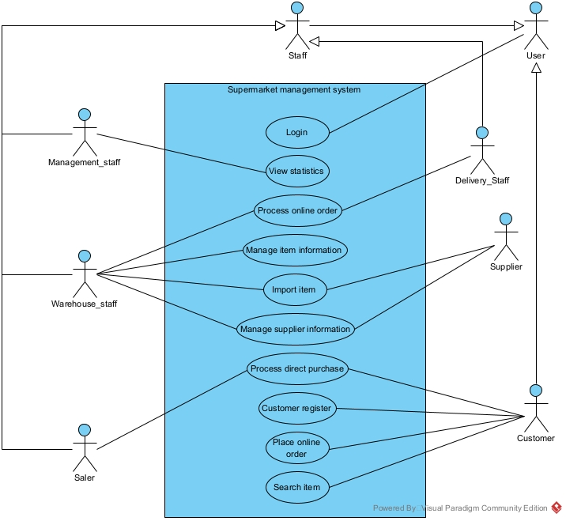
- Description:
  - Login: This use case enable the staff or customer to login into the supermarket system
  - Views statistics: This use case enable the management staff to view the statistic of item, supplier or customer
  - Process online order: This use case enable the warehouse staff to browse the online order place by customer, and can export them to the delivery staff
  - Manage item information: This use case enable the warehouse staff to add new item or change/delete existing item
  - Import item: This use case enable the warehouse staff to import item from supplier
  - Manage supplier information: This use case enable the warehouse staff to add new supplier or change/delete existing supplier
  - Process direct purchase: This use case enable the saler staff to process the direct purchase from customer at the counter
  - Customer register: This use case enable the customer to create an account to log into the system
  - Place online order: This use case enable the customer to place an online order through the system
  - Search item: This use case enable the customer to search the detail of an item through the system
b. Registers as a member
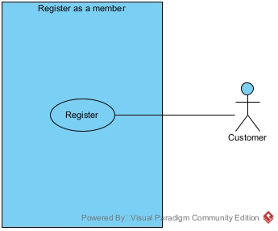
- Register: This use case enable the customer to register as a member in the system
c. Views customer statistics
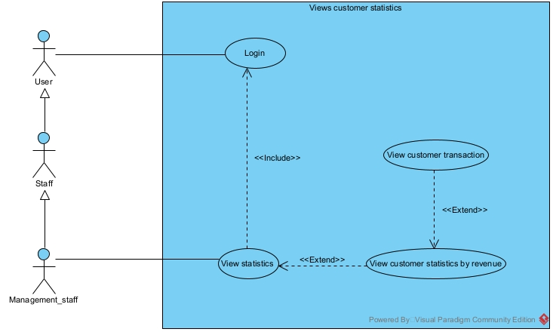
- Login: This use case enable the management staff to login into the system to view customer statistics
- View statistics: This use case enable the management staff to view the item statistics, customer statistics or item statistics
- View customer statistics: This use case enable the management staff to enter start and end date to view the customer statistics by revenue
- View customer transaction: This use case enable the management staff to view all the transaction related to a customer in a specific time frame

